Week 3 Booklet
Monday 30th March – Friday 3rd April
Monday  Spellbound: Week 26  Box 1 Spellings & Sentences  Exercise A&B  Mental Maths  Week 26 Monday | Tuesday  Spellbound: Week 26  Box 2 Spellings & Sentences  Exercise C&D  Mental Maths  Week 26 Tuesday
Wednesday  Spellbound: Week 26  Box 3 Spellings & Sentences  Exercise E&F  Mental Maths  Week 26 Wednesday | Thursday  Spellbound: Week 26  Box 4 Spellings & Sentences  Exercise G&H  Mental Maths  Week 26 Thursday
Friday  Spellings Test – Parent to ask them their spellings  Mental Maths – Week 26 Friday Test | Booklet  The following pages include work to be completed throughout the week. There are English, Irish and Maths activities included in each. Do the work day by day. Do not try and get it all done in one day. Make sure to practice neat presentation and lay your copy page out correctly – Rule, title and date each page.
Wishing you and your families a lovely Easter break. I hope it is a peaceful one and I hope to see you all again soon in the classroom. Please don’t forget that if you need me or my assistance at any stage, don’t hesitate to email me at mrshannonmqa2@gmail.com
MONDAY 30th MARCH

English:
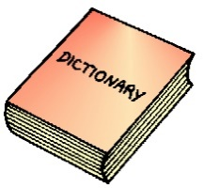Dictionary Detective
Below is a list of incorrectly spelt words. You may need to use a dictionary to correct the spellings.
- Injoy _______________________________________
- Wich _______________________________________
- Adress ______________________________________
- Begininng ___________________________________
- Belevie _____________________________________
- Juring ______________________________________
- Govrmnent __________________________________
- Exept _______________________________________
- Familier _____________________________________
- Sucesful _____________________________________

Reading: Read the story and answer the questions that follow
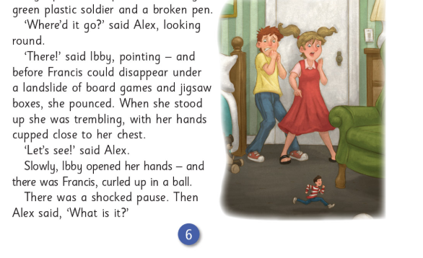
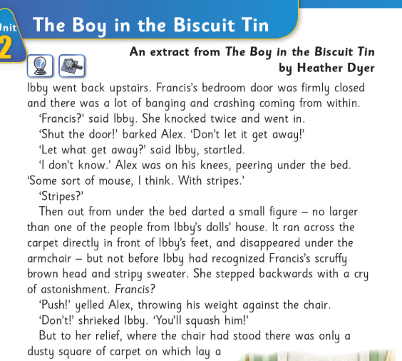

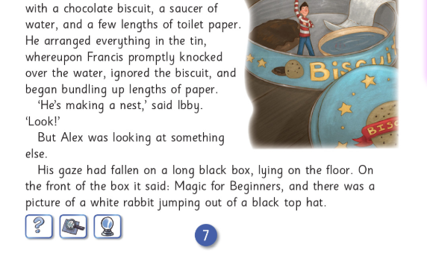
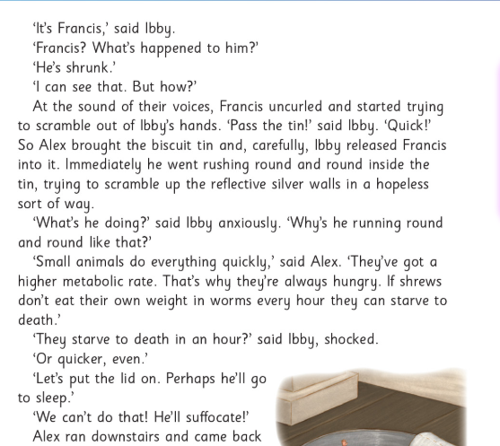

Questions and Answers
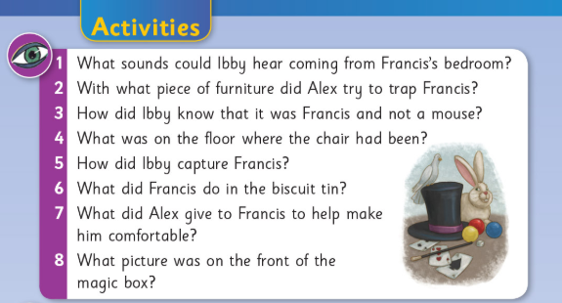

This story is your reading for the week. Each day you will have an activity to do after the reading. If there is someone at home that can listen to you read, this will really help you. You’ve all worked so hard so far this year with your reading so please show how good you are to a parent/guardian!
Don’t forget to keep reading your library books. I want to hear all about them when we are back in school.

Maths: Long Multiplication
Long Multiplication:  First step is to multiply 63x7, which will give us an answer or 441 (7x3=21. Put down the 1 and carry the 2. 7x6=42 plus the 2=44)  Next MAGIC ZERO  Then follow same process – multiply 63 by 3.  Finally – Add the two numbers together  63  $×$ 37  _______________  441  + 1890  2331 |  |  | 34  $×$ 52
76  $×$ 43 | 24  $×$ 31 | 88  $×$ 40 | 52  $×$ 93
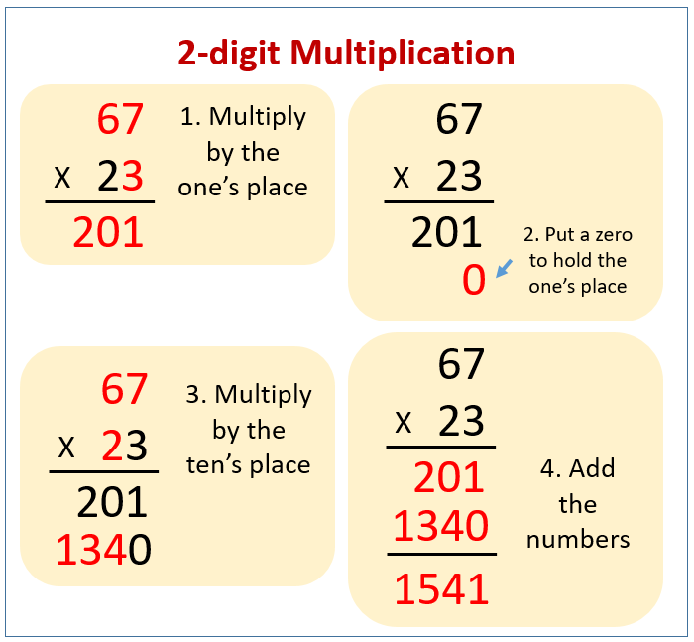

Gaeilge: Nuacht
Chun cabhrú leat (to help you):
Aois (Age):  9: naoi mbliana d’aois  10: deich mbliana d’aois  11: aon bhliain déag d’aois  Rang (Class):  Rang a ceathair | Laethanta na Seachtaine (Days):  (Monday – Sunday)  An Luan  An Mháirt  An Chéadaoin  An Déardaoin  An Aoine  An Satharn  An Domhnach
Inniu (Today)  Inné (Yesterday)  Amárach (Tomorrow)  Eg. Inniu an Luan – Today is Monday  Inné an Domhnach – Yesterday was Sunday  Amárach an Mháirt – Tomorrow is Tuesday | Cén t-am é?  Tá sé.....  ...a naoi a chlog – 9 o’clock  ...leathuair tar éis a seacht – half past 7  ...ceathrú tar eis a cúig – quarter past 5  ...ceathrú chun a trí – quarter to 3  ...fiche chun a deich – twenty to 10  ...cúig tar éis a dó – five past 2
Aimsir (Weather)  Tá an ghaoth ag séideadh  Tá an ghrian ag taitneamh  Tá scamaill sa spéir | Aimsir:  Tá sé fuar  Tá spéir ghorm ann  (There is a blue sky)  Tá sé ag cur baistí

On the next page will be the writing frame for you to write your news. This can be printed out or written in copy (good idea especially for a pen licence!! ).
Mo Nuacht
________________________ is ainm dom. Tá mé _______________ _________ d’aois. Inniu an ______________. Inné an ___________.
Amárach an _____________. (Aimsir) Tá ______________________ agus ____________________________ inniu. (Aimsir inné) Bhí ____ ___________________________ inné. (Aimsir amárach) Beidh ____ ________________________ amárach. (Cén t-am é?) Tá sé _______ _______________.

Tarraing pictúir:

TUESDAY 31ST MARCH
Write down the definition of 5 of the words that you corrected yesterday.
Word | Definition
Maths: Long Multiplication
36  $×$ 27 | 60  $×$ 27 | 30  $×$ 53 | 66  $×$ 93 | 85  $×$ 87

Reading:
Read the story ‘The Boy in the Biscuit Tin’ again and complete the following activity:
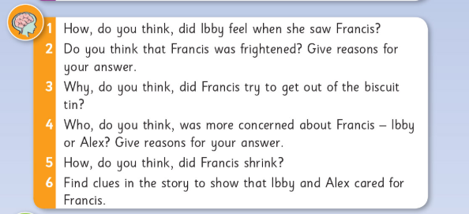

WEDNESDAY 1st APRIL
Put these words into alphabetical order
List One | List Two | List Three
Colour  Couldn’t  Clothes  Climb  cousin  cried | Ground  Going  Gentle  Garden  Grate  Grow | Opportunity  Oxygen  Opposite  Our  Object  O’clock

List one List two List three
- _______________ 1. _______________ 1. __________________

- _______________ 2. _______________ 2. __________________

- _______________ 3. _______________ 3. __________________

- _______________ 4. _______________ 4. __________________

- _______________ 5. ________________ 5. __________________

- _______________ 6. _________________ 6. ____________________

Maths: Weight

Gaeilge:
Mo Nuacht
________________________ is ainm dom. Tá mé _______________ _________ d’aois. Inniu an ______________. Inné an ___________.
Amárach an _____________. (Aimsir) Tá ______________________ agus ____________________________ inniu. (Aimsir inné) Bhí ____ ___________________________ inné. (Aimsir amárach) Beidh ____ ________________________ amárach. (Cén t-am é?) Tá sé _______ _______________.

Tarraing pictúir:

Reading:
Read the story ‘The Boy in the Biscuit Tin’ again and complete the following activity:
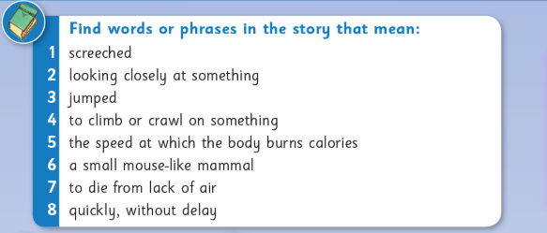

THURSDAY 2nd APRIL
Some words have very similar meanings. You can use your dictionary to discover how they are different. Look up the words below in a dictionary and write down what is slightly different about them.
- Hill, peak, mountain, fell
- Street, path, lane, road
- Horror, fright, terror, fear
  - Write the meaning below
- Hill: ______________________________________________
- Peak: ____________________________________________
- Mountain: ________________________________________
- Fell: _____________________________________________

- Street: ____________________________________________
- Path: _____________________________________________
- Lane: _____________________________________________
- Road: _____________________________________________

- Horror: ____________________________________________
- Fright: _____________________________________________
- Terror: _____________________________________________
- Fear: _______________________________________________

Maths: Weight
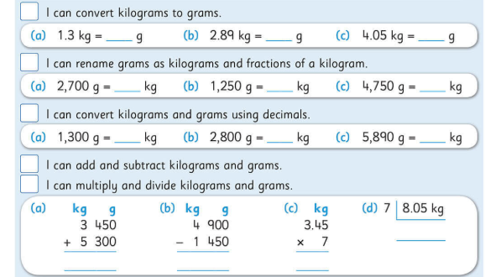
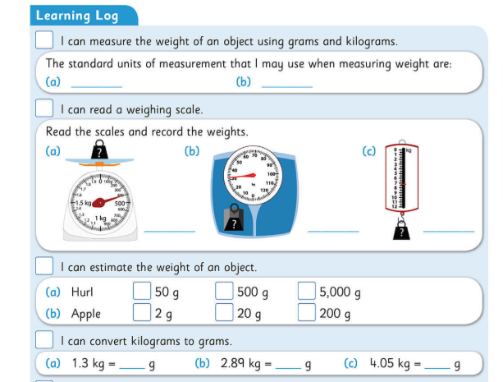

Read the story ‘The Boy in the Biscuit Tin’ again and complete the following activity:
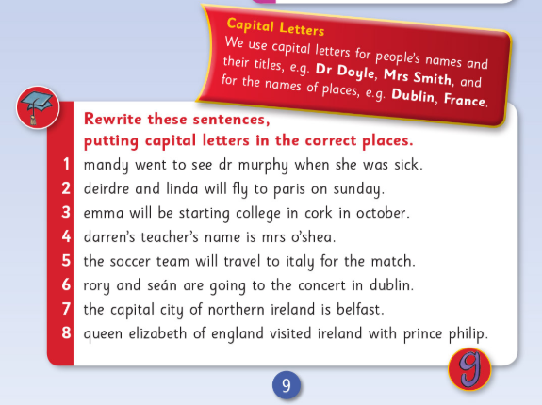

FRIDAY 3RD APRIL
A dictionary tells you what type of word you have looked up. It tells you whether it is an adjective, noun or verb, etc. Look up the following words below and write what kind of word they are.
Octopus _________________________________________________
Myself__________________________________________________
Little____________________________________________________
Library__________________________________________________
Jupiter__________________________________________________
Amazingly________________________________________________
Quietly__________________________________________________
Jolly____________________________________________________
Glasses__________________________________________________
Bucket__________________________________________________
Knock___________________________________________________
Admire__________________________________________________

Reading:
Read your library book for 15 mins. If you don’t have one, check out the class blog for links to online books or check with a sibling and see if you can borrow one.

Maths: Weight
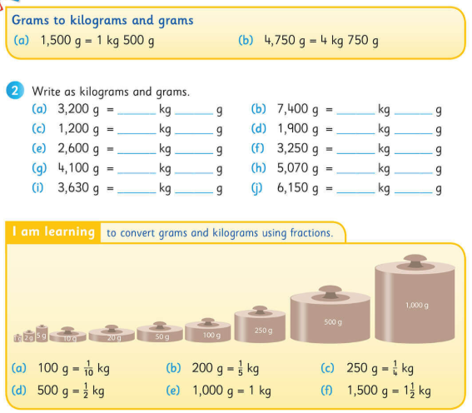
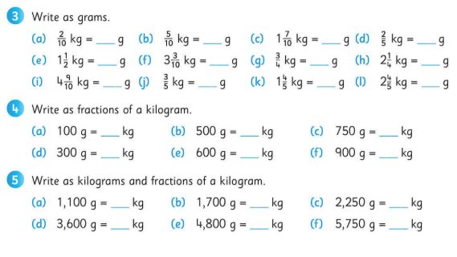

Easter Colouring:

