Monday:
- Spellbound unit 25 A and B
- Sentences
- Read at home week 24 Day 1 and questions
- Master your Maths week 24 Monday
- Fuaimenna agus focail unit 17 A and B
- Exercise for 30 mins

Please find extra worksheets below:
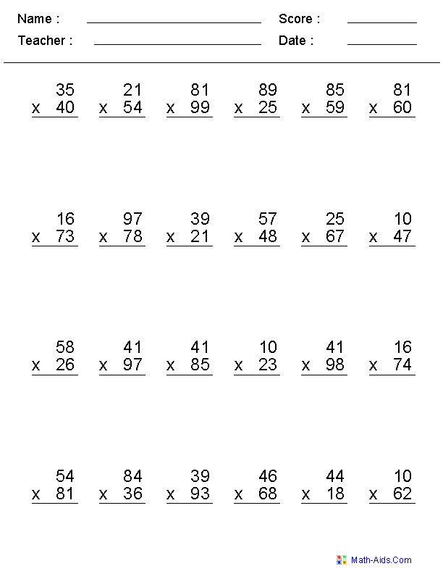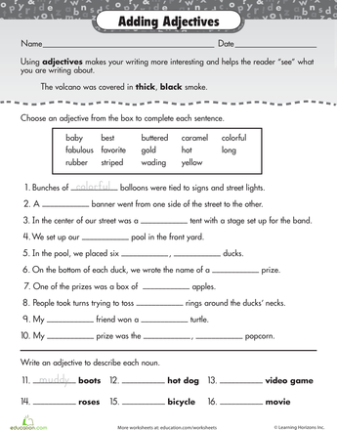

Tuesday:
- Spellbound unit 25 C and D
- Sentences
- Read at home week 24 Day 2 and questions
- Master your Maths week 24 Tuesday
- Fuaimenna agus focail unit 17 C and D
- Read for 15 minutes and write a prediction of what you think will happen next

Please find extra worksheets below:
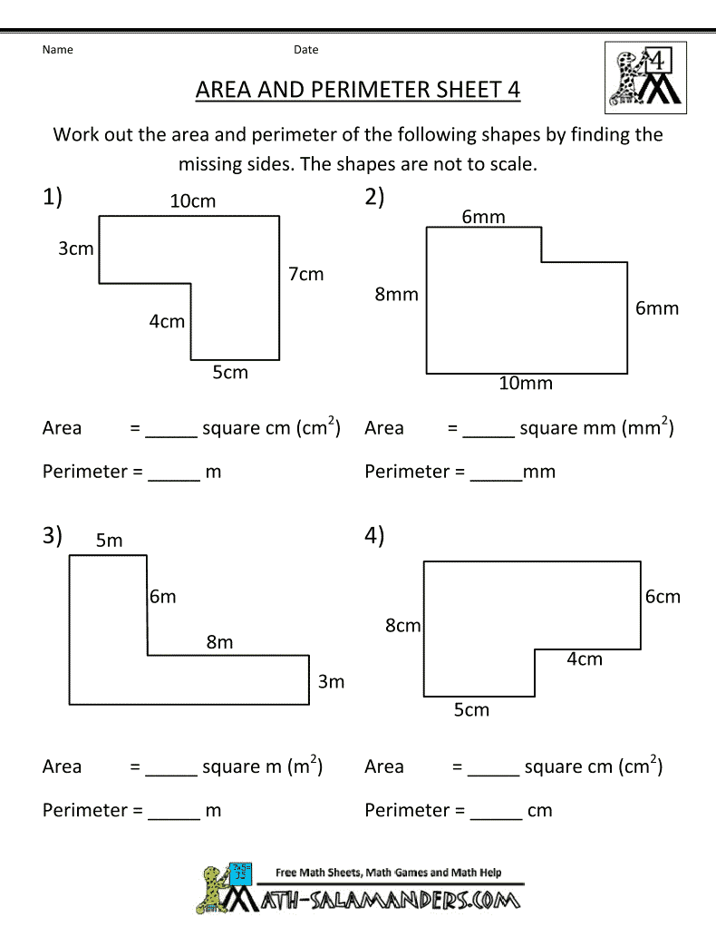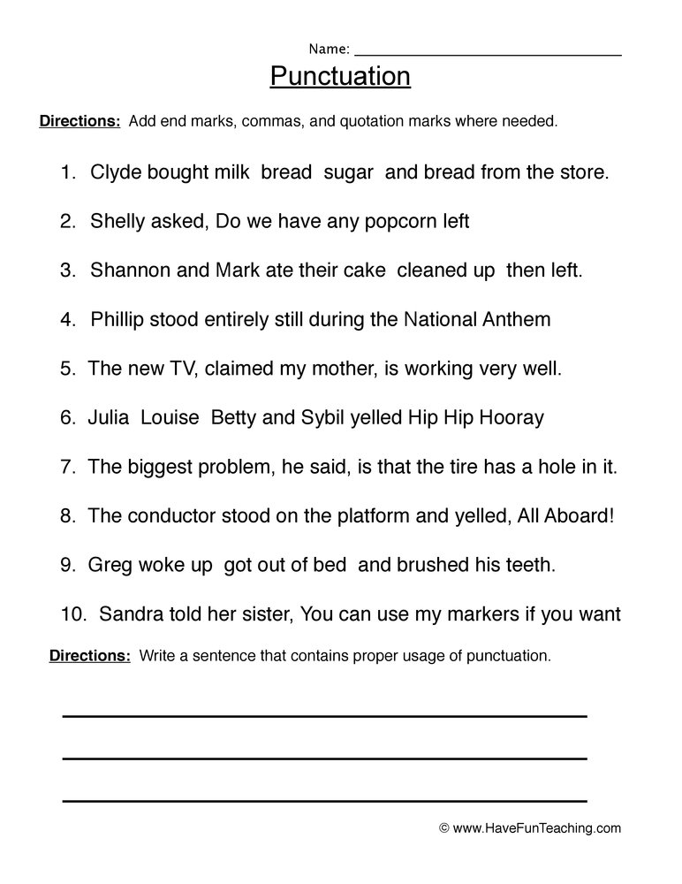

Wednesday:
- Spellbound unit 25 E and F
- Sentences
- Read at home week 24 Day 3 and questions
- Master your Maths week 24 Wednesday
- Fuaimenna agus focail unit 17 E and F
- Write a story based on “A Friendly Alien that comes to Earth”.

Please find extra worksheets below:

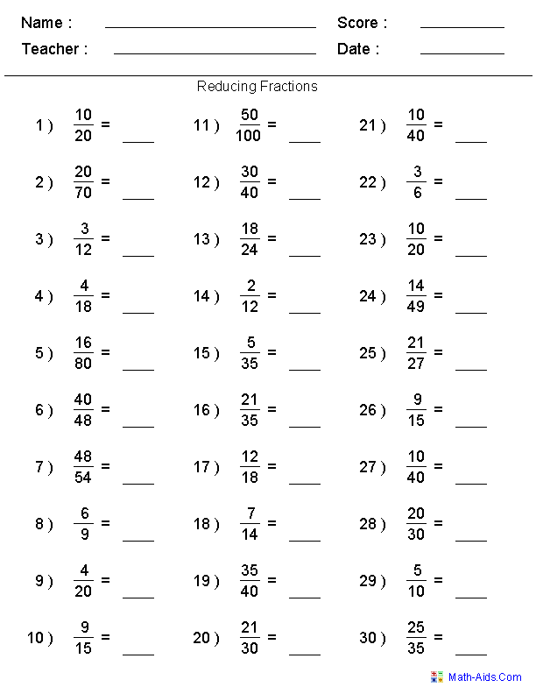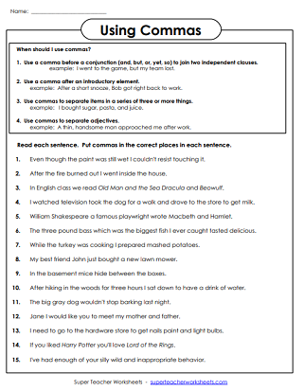

Thursday:
- Spellbound unit 25 G and H
- Sentences
- Read at home week 24 Day 4 and questions
- Master your Maths week 24 Thursday
- Fuaimenna agus focail unit 17 G and H
- Project: Choose your favourite animal and find out 15 interesting facts.

Please find extra worksheets below:
